POWER BI VISUALS
- Snow flake Datasets
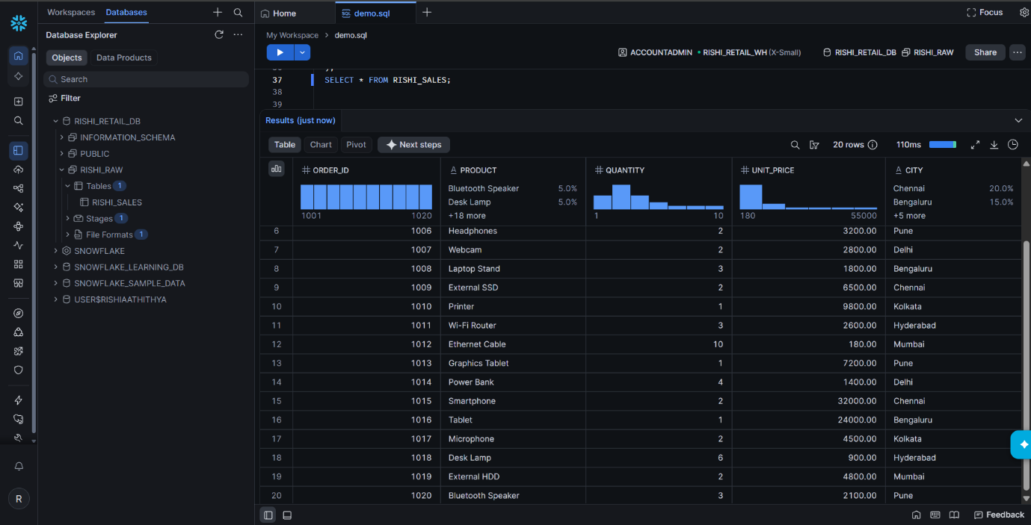

- Snowflake Account Details
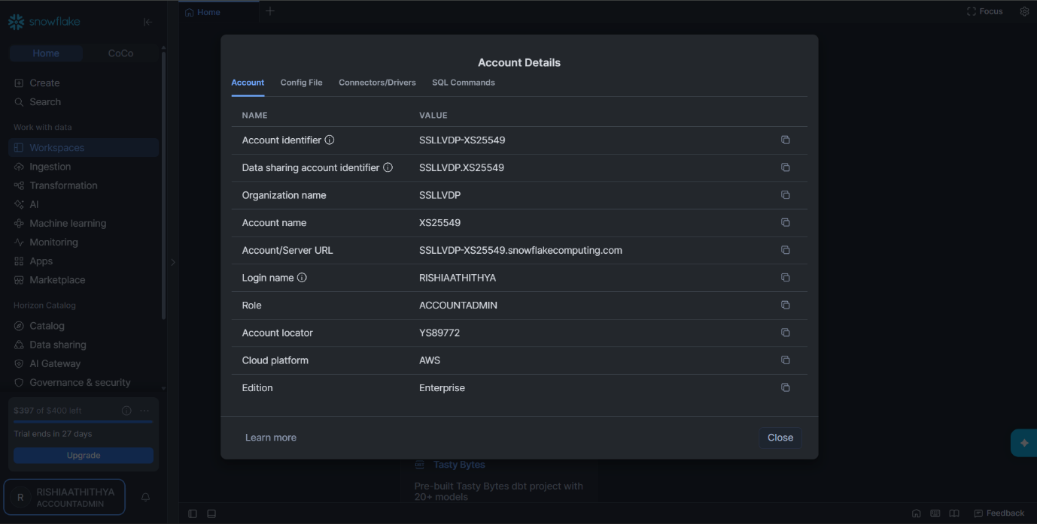

- Snowflake to Power Bi Connection:
Selecting the Datasource as the Snowflake
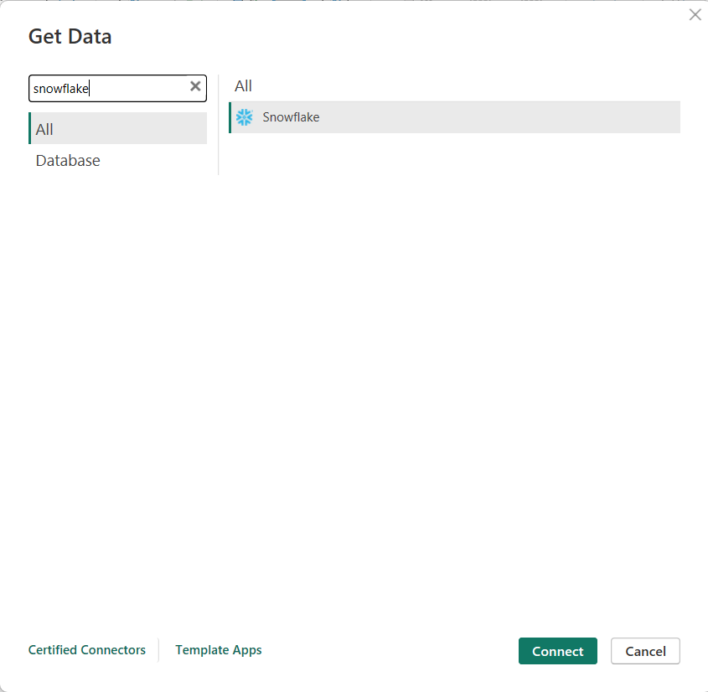

Giving our Credintials like
Server url and Warehouse name
Credenetials like Username and Password

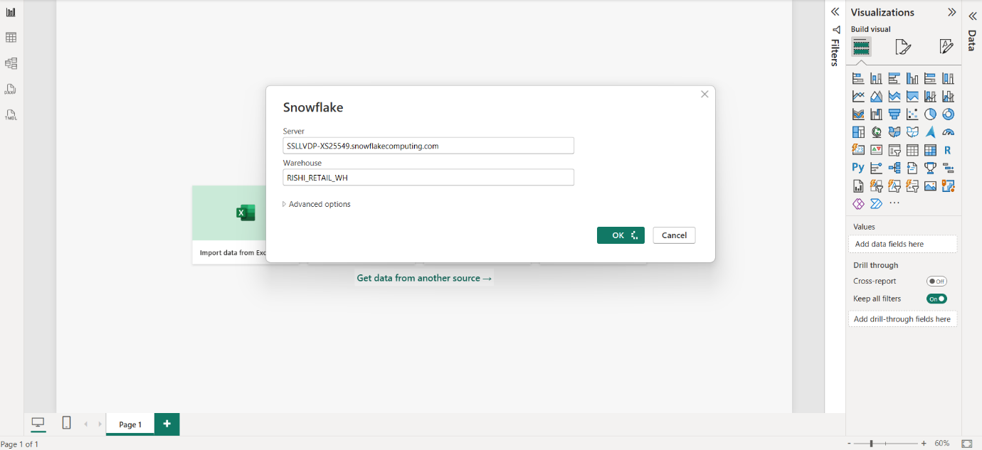

- Power Bi Visuals
Structred Bar Chart : Revune By Product
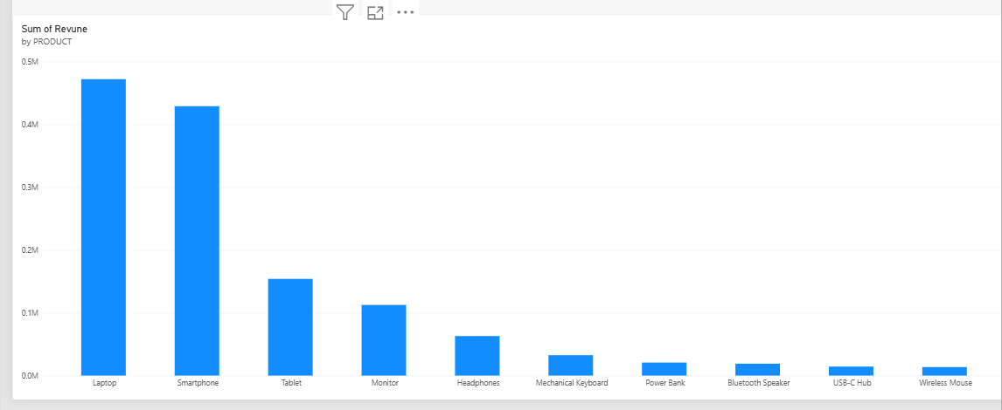

Line Chart : Revune by Month and Date
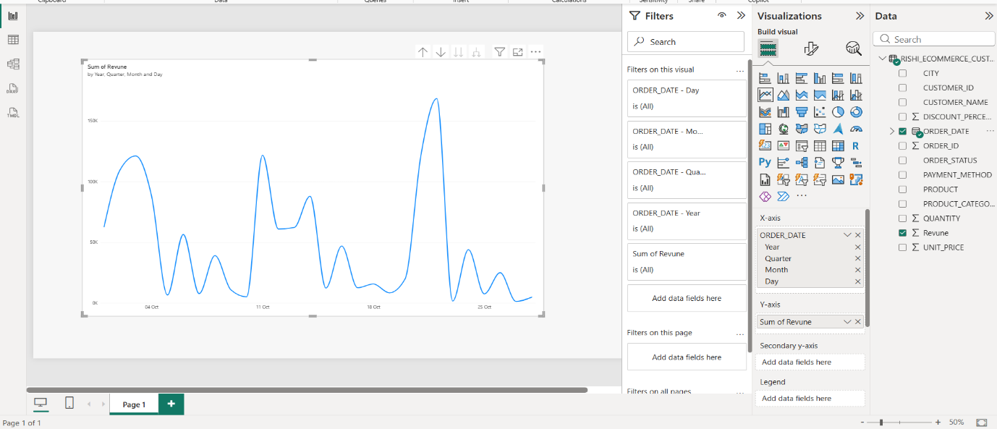

PieChart : Total Revune Based on the Each Categories
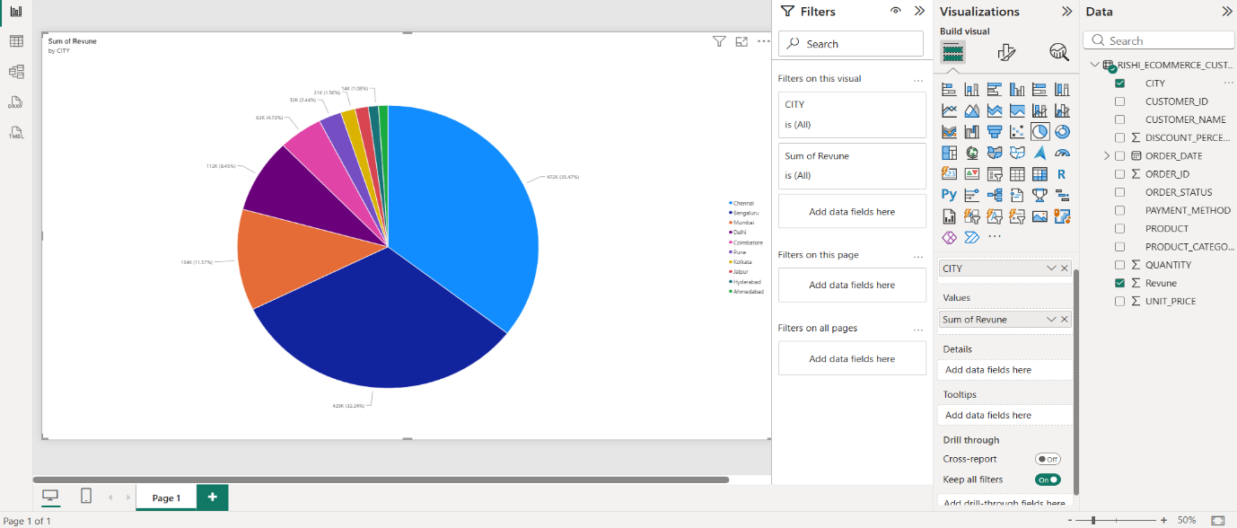
Line Chart of Revenue Showing of the Month year and data with City:
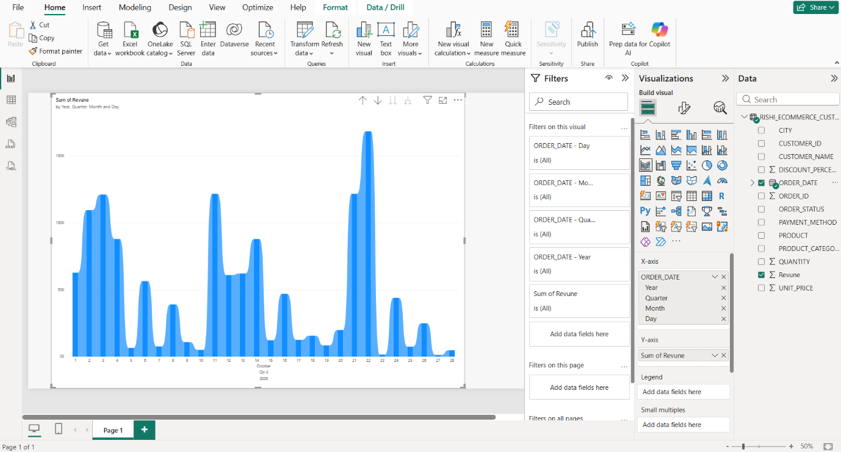

Slicer :
Dashboard = Structred Column Chart + Card + Line Chart with slicer
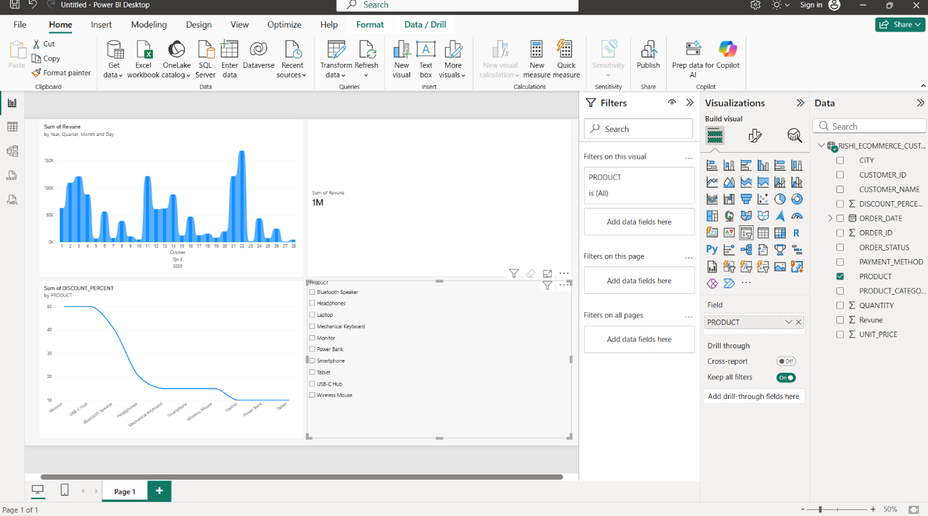

Dashboard with all Collection :

Average Order + Total Customer + Total Orders + s Total Revune


